Name: Harshavardhan Subramanian Manikandan

Candidate Id: 225099902

CONTENTS

PROJECT PLAN………………………………………………………………………………………………1

HTML………………………………………………………………………………………………1

CSS……………………………………………………………………………………….…………3

JAVASCRIPT…………………………………………………………………………….…………5

CONCLUSION………………………………………………………………..…………………….7

REFERENCES AND SOURCES…………………………………………………………………………………..……….7

PROJECT REPORT

Project Plan

In this project report, I will give a complete overview of the project about creating a webpage that contains my Personal Development Plan using simple words.

My primary goal is to unleash my creativity and knowledge by making an attractive table and adding animations using CSS.

After spending more than 7 hours on this project, all of my goals have been achieved. They include:

* Using almost necessary HTML, CSS and JavaScript for this webpage.
* Adding audio and brand-new animations.
* Learning how to make a new website.

HTML

Like in every webpage, certain basic tags are mandatory for creating the framework of a page (tags like <html>).

In the webpage (PDP Page) that I made, the table (made using the <table> tag) is seen as the key component which has all the important details of the plan.

I have also added a:

* hyperlink (<a>)
* 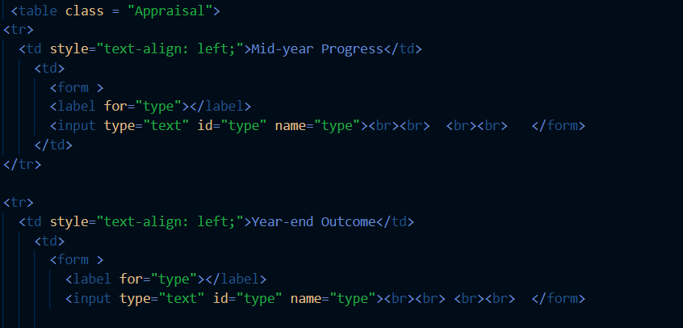text box (<form>, <label>, <input>)
* header
* audio (<audio>), which will be played and paused by pressing the button (<button>) in the nav bar (JavaScript is used for proper functioning, which will be discussed in that section).



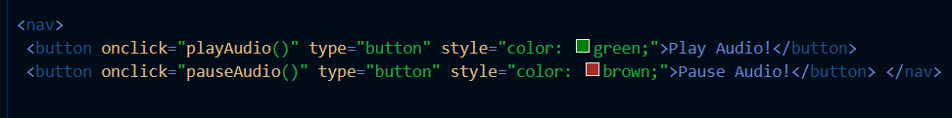

button in <nav>

CSS

Using CSS,

* Background images and also animations of images are added.
* Certain Fonts have been imported from Google Fonts (Roboto, Poller-One).
* Appropriate measure of “Padding”, “Margin”, “Letter-Spacing”, and “Text-Alignment” has been done for the table and heading.
* Animation of the header is made by using “scale()” attribute (Seen in Animation)

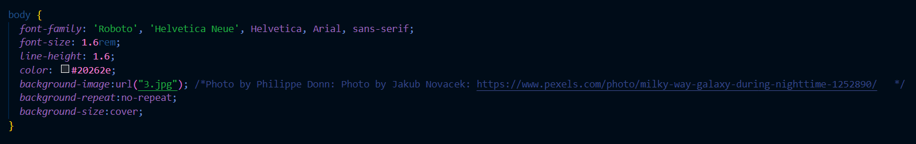

CSS attributes for the contents in <body>

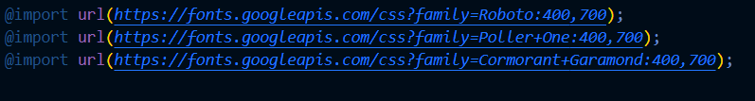

Importing Fonts from Google Fonts

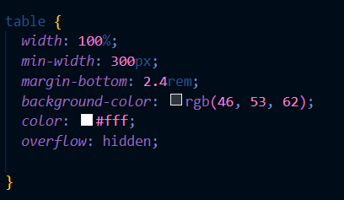

CSS attributes for <table>

Special Elements

* **“nth-child(odd)”**: Using this attribute, I can apply changes to each “odd” row of the table.
* **“first-child” and “last-child”**: These refer to the first row and last row of the table respectively. 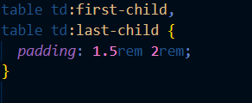
* **“::before**”: This pseudo-class is used to change or add attributes before any tag.

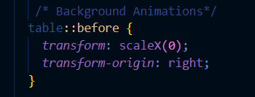

Animations

Using the following elements, I could add animations to the background images

* **“transform: scale ()”:** Change the size of the background image
* **“z-index (-1)”:** Prevent overlapping of the image with the table.
* **transition: transform 2s”:** Refers to the transform attribute and also the time of the animation.

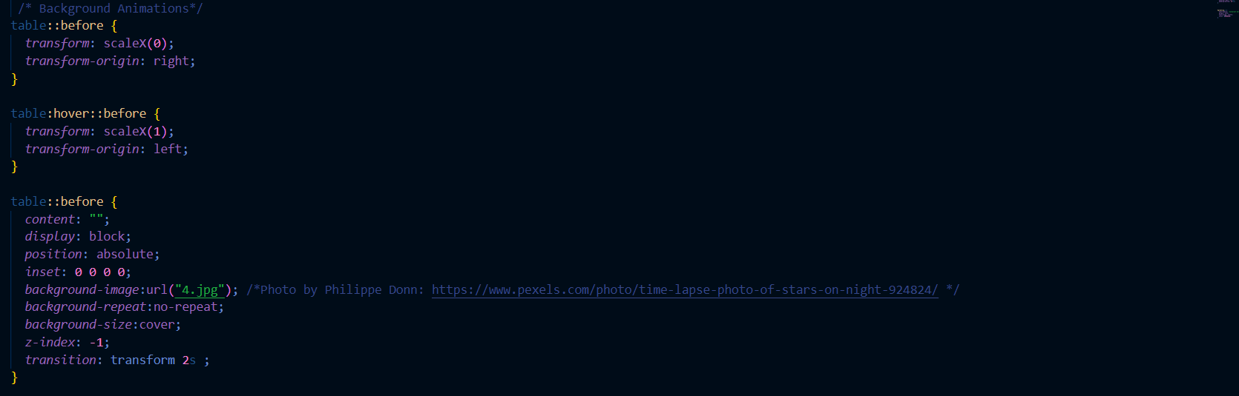

Animation of the background image

JAVASCRIPT

With the help of JavaScript,

* The user could type their name and be displayed on the page.

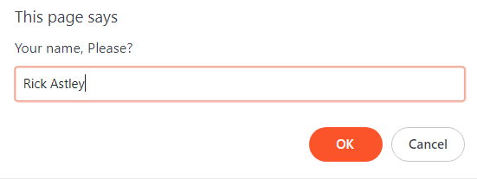

A “Pop-Up “asks for the user’s name before the webpage opens.



The user’s name is displayed on the webpage.

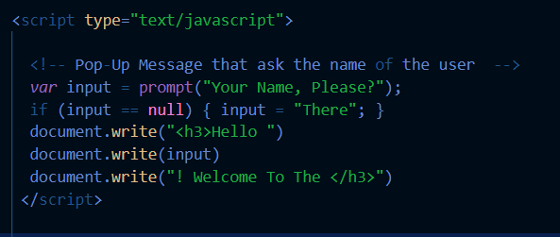

This script enables to have the pop-up and also display the name

* They can play and pause the music.

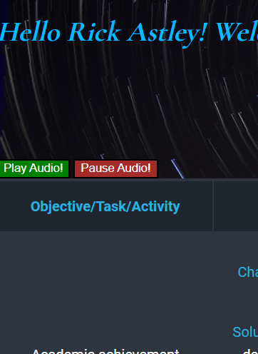

Play and Pause Button as seen on the webpage.

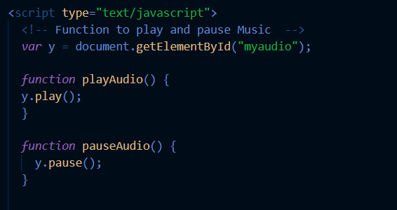

This script is required for controlling the music.

Conclusion (Project Evaluation)

By doing this assignment, I came to the conclusion that I have learned about the process of making a website and I believe I have mastered it.

The only major problem that I faced was regarding the audio tag. The audio was not playing automatically even after having the “Autoplay” attribute. The problem was resolved by introducing buttons and using JavaScript for playing audio.

References and Sources

* W3Schools
  + HTML: <https://www.w3schools.com/tags/>
  + CSS: <https://www.w3schools.com/cssref/index.php>
  + Audio Function: <https://www.w3schools.com/jsref/met_audio_play.asp>
* Audio
  + <https://musopen.org/music/43229-solfeggio-in-c-minor-h-220/>
* Background Images:
  + <https://www.pexels.com/photo/milky-way-galaxy-during-nighttime-1252890/>
  + <https://www.pexels.com/photo/time-lapse-photo-of-stars-on-night-924824/>
* Video Hyperlink:
  + <https://www.youtube.com/watch?v=NwLGHCZTQt4>
* Table Template
  + <https://codepen.io/pablorgarcia/pen/ARdVgx>